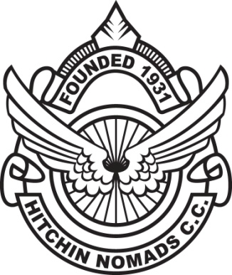

Hitchin Nomads Cycling Club

Committee Meeting: 22nd October 2018, 20:00

Venue: Casa Thomson, Hitchin

Present:
Ross Thomson Membership & Club Secretary
John Watson Club Captain
Dave Rickels Road Race Secretary
James McPherson Treasurer
Nick Senechal ……………………….Youth Development
Meliné Fletcher Madam Chairman
Julian Pegg Time Trial Secretary

Apologies for Absence:
Nigel Wilson Records Officer
Steve King……………………………..Deputy Road Race Secretary
Tom Morris Welfare Officer
Phil George Club Ride Coordinator
Sue Clifford-Smith…………………News Editor

 | Action
- Minutes of meeting held on Monday 24th September 2018
  - The minutes of the meeting were ratified as a correct record.
- Matters arising:  - Web Site – Committee recognised the work to date from Sue C-S, photo archive is being updated, DR assisting SC-S in revamping.  - Ratified minutes to be sent by RT via e-mail to the membership as opposed to put on the website, due to recent phishing incident. RT to make backdated minutes available, upon request from members.  - RT to confirm website is now live, a work in progress when circulating ratified minutes.  - Monthly Calendar – Ann Collins prepares the calendar for circulation and is greatly appreciated. Members & committee to keep her updated.  - 2019 Awards – MF reported that Roger & Nigel had preparations in hand.  - Three new trophies to consider: i) services to club – male; ii) services to club - female and Club Run leader, to be known as Jarman Award. MF to speak to Roger/Nigel in relation to costs of new trophy, which the Jarman family wish to pay for.  - Club to cover trophy costs this coming year, then cost to be put to membership who pays for them going forward.  - MF proposed that AGM and awards held at the same time to encourage attendance, penciled in 15th March 2019 – venue and details to be confirmed, supported by committee.  - Event Scheduling – Events for 2019: 18th May 2019 has been confirmed with LNDC now for Club 25. DR to fix road race in Sept 2019, date tbc.  - JW proposed an offline Calendar meeting attended by NS, JW, JP & DR. Interclub dates to be investigated and schedule to be confirmed for November meeting.  - Road Race – DR reported a positive event. Plans to hire the school for next years HQ. To host two races, two sets of race numbers required for next year – committee approved this expenditure. DR reported approx. 35 club members gave their time on the day to make the event such a success. | DR/SC-S  RT  RT  All  MF/RT  All  NS, JW, JP, DR
3. Officers Reports  - Kit Administrator - CJ to make a pre Xmas order, approved by Committee. JW to confirm.  - Madam Chair – List of BC administrators to be reviewed and updated ahead of November meeting to comply with regulations.  - TT Secretary – Boxing Day 10 , JP to consult with NH which roles need handing over and report back for November meeting.  - Levies to be arranged for end of year – JP to check with Leanne and report to JMc.  - Club Captain – Club Social confirmed for 30th November.  - Youth Development – NS confirmed a Muddy Monsters event for 24th November. Henlow Club Cluster sessions – NS encouraging attendees to join clubs, as family members. NS confirmed Brian Ruggles to become a coach, sponsored by Club Cluster and he is to coach a number of predetermined sessions thereafter. | JW, CJ  MF  JP/JMc  NS
- Any Other Business
  - Next committee meeting will be Monday 19th November

